SiteScope: An End-to-End Schedule-Driven Robotic Workflow for Construction Progress Monitoring
Aklile T. Mengiste, Samuel A. Prieto, Member, IEEE and Borja García de Soto, Member, IEEE
Abstract— Construction progress monitoring is challenged by dynamic site conditions, fragmented data collection, and reliance on manual inspections, which limit monitoring frequency, consistency, and scalability. This paper presents SiteScope, an end-to-end workflow integrating recurring inspection schedules with autonomous robotic navigation and 360-degree image capture, automated evidence ingestion, and human-verified report publication. A controlled laboratory study compares scheduled robotic and manual workflows for producing the same four-location inspection package. Across five paired trials, all scheduled robotic missions completed the inspection route, while both workflows produced all expected images and reports without failures, interventions, or retries. End-to-end elapsed time decreased from 10 min 20 s ± 26 s for the manual workflow to 7 min 25 s ± 8 s for the scheduled robotic workflow, a 28.2% reduction under the evaluated conditions. The scheduled workflow also reduced recurring human attendance, although it required greater one-time setup and used a fixed-height camera configuration. These results demonstrate the feasibility and operational benefits of an integrated schedule-to-report workflow while identifying setup effort and sensing flexibility as important considerations when interpreting the comparison.

INTRODUCTION
Timely construction progress information supports schedule control, coordination, payment assessment, and early identification of deviations. Conventional documentation requires personnel to prepare capture equipment, visit work areas, collect evidence, transfer and organize files, interpret site conditions, and prepare reports. These repeated activities consume skilled human time and make inspections difficult to reproduce consistently. Because the manual and robotic workflows involve different tasks, personnel, and equipment, this study follows the activity-level process-comparison approach in [1].
Prior research has addressed complementary elements of construction progress documentation. Panoramic imagery has been investigated for construction visualization and progress monitoring [2], while robotic systems have combined SLAM, autonomous exploration, and reality capture for site data acquisition [3], Other work has automated the spatial organization of 360-degree imagery through room-level labelling [4] and used inspection information with project schedules to support automated progress analysis and reporting [5]. These approaches automate acquisition, spatial organization, or analysis, but do not connect a due recurring inspection with scheduled robotic execution, automatic location-aware evidence ingestion, human review, and PDF report publication in one traceable workflow.
This paper makes three contributions: (1) an implemented schedule-to-report workflow connecting recurring scheduling, autonomous navigation, 360-degree acquisition, automatic ingestion, and human-verified report publication; (2) a provenance-preserving pipeline associating each asset with its project, location, date, mission, waypoint, sensor, and robot pose; and (3) a paired activity-level comparison of manual and scheduled robotic workflows that accounts for one-time setup, recurring elapsed time, required human time, personnel, and equipment. The comparison concerns the specific workflow configurations evaluated in this study and does not claim equivalent sensing flexibility or general superiority of one inspection method. The study does not claim automated contractual percent-complete assessment.

SiteScope Workflow and Process Definition

A. System Architecture
SiteScope combines a Unitree Go2-Wheeled mobile robot equipped with an NVIDIA Jetson Orin NX, an Insta360 X4 camera, and a Livox MID-360 LiDAR with ROS 2/Nav2 and a cloud-connected web platform for scheduling, mission coordination, evidence management, review, and reporting. A recurring schedule defines the project workspace, robot, local execution time and time zone, capture mode, and ordered capture points. When a scheduled occurrence becomes due, the backend creates a mission that is claimed by the robot agent. The agent executes the ordered route, captures the requested evidence at each waypoint, uploads the resulting assets, and returns to the saved home pose.
During ingestion, SiteScope associates each asset with its project, location, date, mission, waypoint, sensor, and robot pose before making it available in the media library. A reviewer then opens the selected evidence, adds annotations and observations, and initiates report generation. Using the configured report template, SiteScope assembles the selected evidence and saved review information into a PDF, while interpretation, verification, and publication remain under human control.
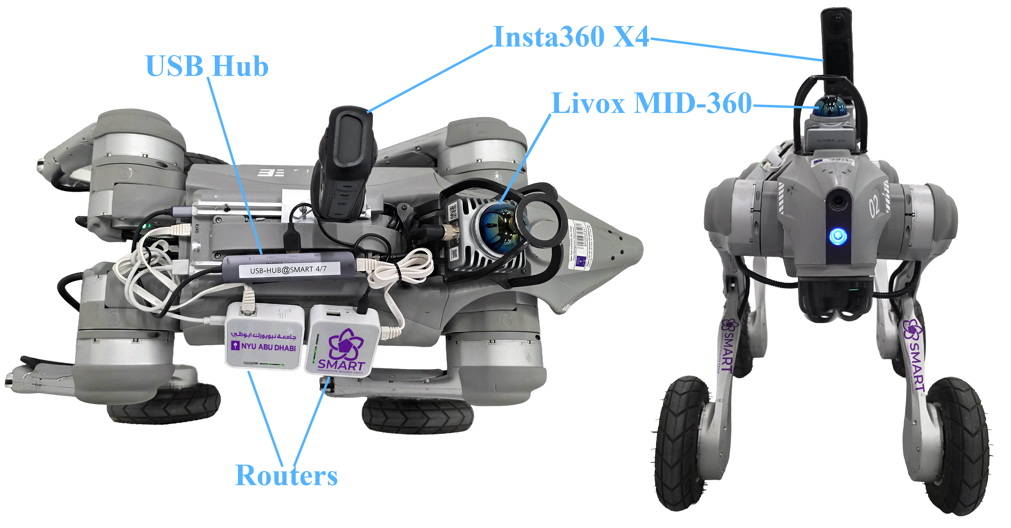
(a) | (b)
- SiteScope robotic platform and integrated sensing payload: (a) top view and (b) front view.

B. Integrated Workflow and Comparison Processes
Fig. 2 summarizes the schedule-to-report architecture and the activity identifiers used in the comparison. S-M1 defines the one-time manual route, while S-R1–S-R5 establish the persistent robotic configuration detailed in Table I. During recurring execution, the manual branch comprises camera preparation (M1) and capture, transfer, and upload (M2). The robotic branch comprises startup (R1), automatic mission creation, and autonomous navigation, capture, upload, and return to H (R2). Both branches converge when evidence becomes available in SiteScope, where it is stored with provenance and processed through the shared review-and-reporting subprocess C1. Table II reports the recurring measurements.
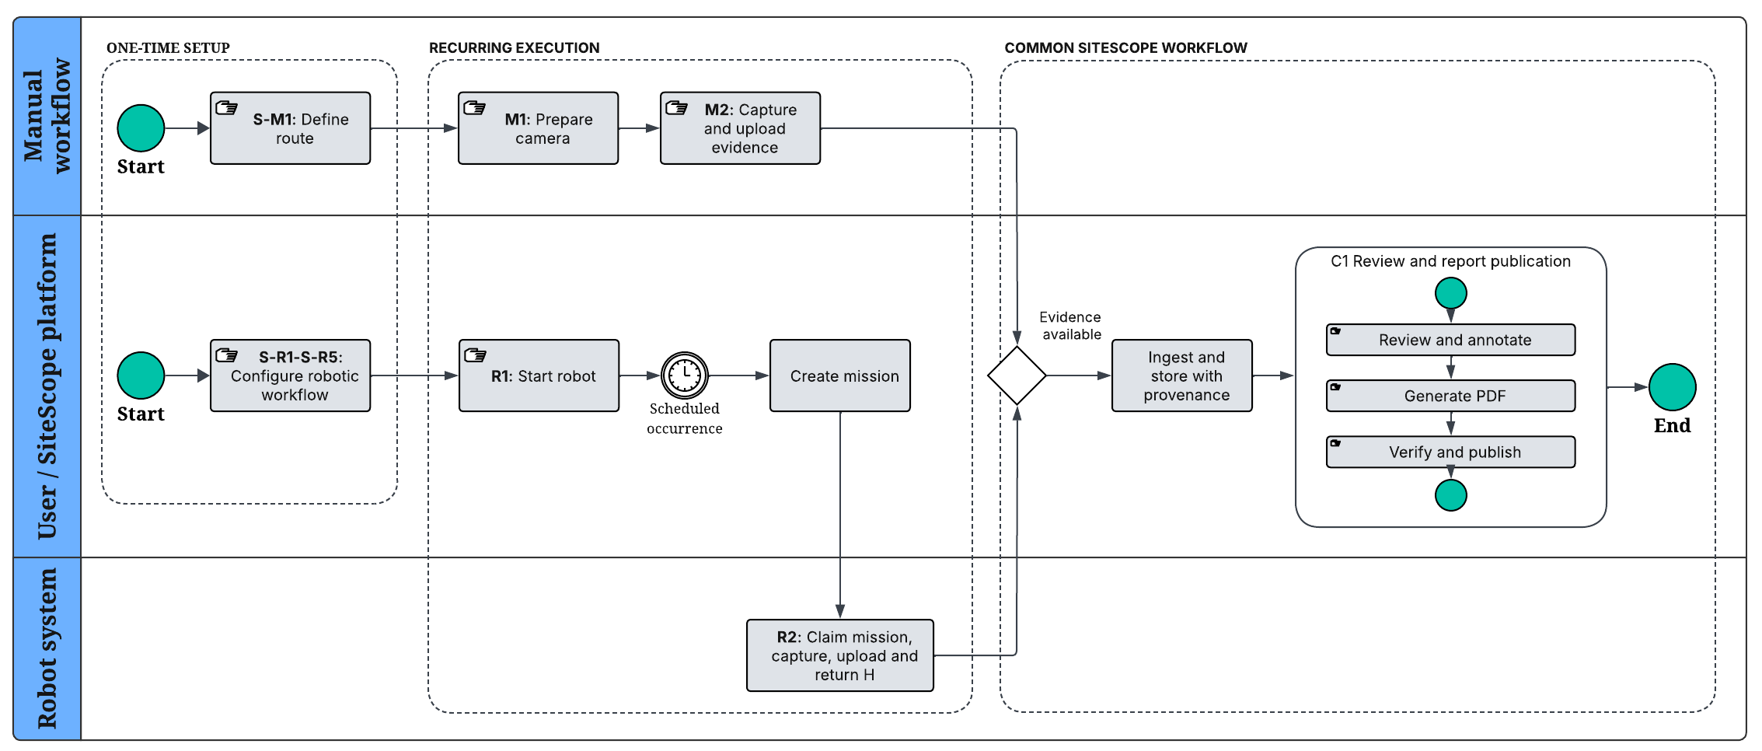
- SiteScope schedule-to-report workflow showing one-time setup, recurring manual and robotic execution, and report publication.

Case Study and Comparison Method

Controlled Laboratory Setting and Functional Unit
The evaluation used four predefined capture points (CP1–CP4) within and immediately adjacent to a controlled indoor laboratory. Each point was defined by a map position and orientation, while H was the saved start and return pose Fig. 3(a). The ordered visit sequence, execution time, time zone, recurrence, and capture mode were configured through the recurring schedule Fig. 3(b).

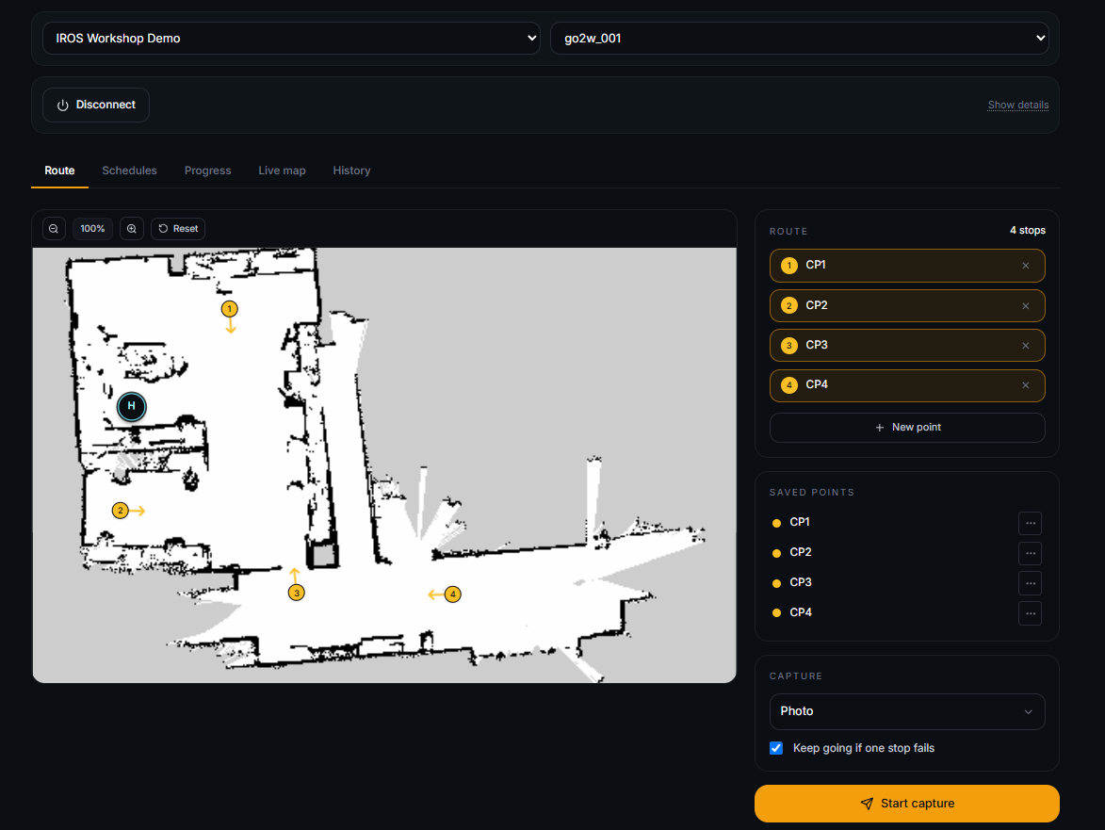 | 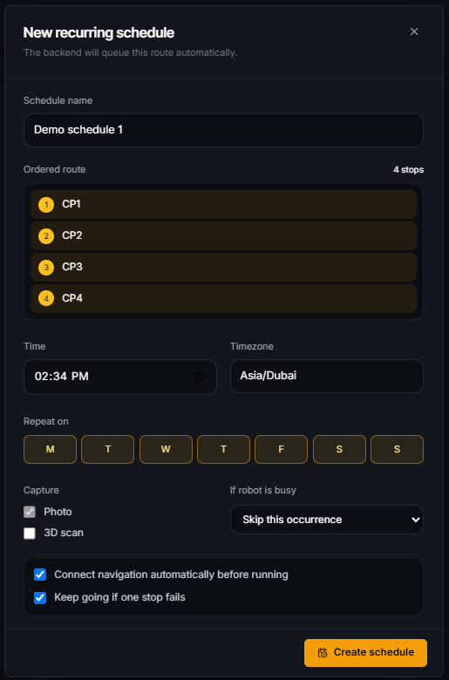
(a) | (b)
- SiteScope inspection configuration: (a) robot navigation map with the ordered capture points; (b) recurring inspection schedule configuration.

Each run produced four usable 360-degree images and one PDF report. The CP1 image supplied the standardized evidence for one annotation and one observation. Both workflows used the same project, route, capture-point labels, report template, camera model, and settings: 360 photo mode, 72 MP JPEG, automatic exposure, and HDR off. The manual camera was mounted on an adjustable tripod/selfie-stick at 1.25 m, whereas the robot-mounted camera remained fixed at 0.67 m. Accordingly, the timing results characterize the tested workflow configurations rather than their broader inspection capabilities. Point-cloud capture was excluded.

Paired Experimental Protocol
Five paired trials, comprising ten recurring runs, were conducted, alternating Manual–Robot and Robot–Manual order. The one-time activities S-M1 and S-R1–S-R5 are shown in Fig. 2 and reported in Table I; they were excluded from the recurring averages in Table II. Both conditions used the same route, scene, camera settings, Internet connection, workstation, user, annotation instructions, and report template. S-R1 was treated as one-time because the integrated robot payload remained mounted, whereas each manual trial began with the X4 powered off and detached, requiring M1. A permanently mounted or pre-staged manual camera would reduce recurring M1.

Timing Boundaries and Measures
Manual workflow: Each trial began with the X4 powered off and detached. M1 covered mounting the camera, extending it to 1.25 m, powering it on, and checking readiness. M2 covered route traversal, capture at CP1–CP4, return to the workstation, file transfer, and upload, ending when all images were available in SiteScope.
Scheduled robotic workflow: The robot began at H with the integrated payload mounted and powered off. R1 ended when the robot was online and ready; standby before the scheduled occurrence was excluded. R2 covered autonomous navigation, capture, upload, and return to H, ending when all images were available.
Table II summarizes the recurring measurements. Evidence-availability elapsed time was M1 + M2 for the manual workflow and R1 + R2 for the robotic workflow. Required human time included all of M1 and M2 but only 5 s of active input during R1; R2 required no attendance. C1 began when the CP1 image rendered and ended when the published PDF opened. During C1, the reviewer added the standardized annotation and observation, SiteScope generated the PDF, and the reviewer verified and published it. C1 was excluded from evidence-availability measures and included in the end-to-end totals..

- PERSONNEL, EQUIPMENT, AND DURATION FOR ONE-TIME WORKFLOW SETUP
(a) Manual one-time experimental route setup
ID | Measurable action | Personnel | Equipment | Elapsed time (min:s)
S-M1 | Complete manual route setup: select CP1–CP4, define the route order, and place the labelled floor markers. | 1 user | Plan/sketch, floor markers, labels. | 4:47
(b) Scheduled robotic one-time setup
ID | Measurable action | Personnel | Equipment | Elapsed time(min:s)
S-R1 | Mount and connect camera and payloads. | 1 user | Go2W, X4, mounts, cables, restraints, tools. | 2:40
S-R2 | Create navigation map and save home pose. | 1 user | Go2W, workstation/controller. | 8:32
S-R3 | Pair robot with the SiteScope project. | 1 user* | Go2W, Internet-connected workstation. | 1:08
S-R4 | Upload navigation map and define CP1-CP4. | 1 user* | Internet-connected workstation. | 2:14
S-R5 | Create and enable the recurring schedule. | 1 user* | Internet-connected workstation. | 0:57
Total | Sum of robotic setup actions. |  |  | 15:31
Project-owner permission was required for S-R3–S-R5.
- PERSONNEL, EQUIPMENT, AND TIME FOR RECURRING INSPECTIONS
ID | Measurable action | Personnel | Equipment | Elapsed time (min:s) | Required human time (min:s)
M1 | Mount camera on support, extend to 1.25 m, power on, check battery and storage, and connect to phone. | 1 user | X4, selfie stick, tripod | 2:26 ± 0:17 | 2:26 ± 0:17
R1 | Turn on robot. | 1 user | Go2W with payloads, dedicated workstation. | 2:00 ± 0:06 | 0:05
M2 | Traverse route, capture four images, copy files, and upload each image with date and location. | 1 user | X4, selfie stick, USB/card reader, Internet workstation. | 7:02 ± 0:20 | 7:02 ± 0:20
R2 | Execute scheduled mission, navigate to CP1-CP4, capture and upload images, and return home. | None | Go2W with payloads | 4:33 ± 0:04 | 0:00
C1 | Review CP1 image, save standardized annotation and observation, generate report, and open published PDF. | 1 user | Internet-connected workstation. | 00:52 | 00:52
Manual total | Sum of listed recurring manual actions. |  |  | 10:20 ± 0:26 | 10:20 ± 0:26
Robot total | Sum of listed recurring robotic actions. |  |  | 7:25 ± 0:08 | 0:57
M1, M2, R1, and R2 are reported as mean ± sample standard deviation across five trials. C1 is a single standardized measurement applied equally to both workflows.

Results and Discussion

Workflow Feasibility and Timing
Across five paired trials, all 5/5 scheduled robotic missions completed the four-capture-point route and returned to the home position. Each workflow produced all 20 expected images and five published PDF reports, with no mission or upload failures, retries, or unplanned interventions. One-time setup required 4 min 47 s for the manual route and 15 min 31 s for the scheduled robotic workflow. The greater robotic setup effort comprised payload integration, mapping and home-pose creation, robot pairing, capture-point definition, and schedule configuration; these reusable activities were excluded from the recurring averages but remain relevant when considering one-off or infrequent inspections.
The manual workflow required 9 min 28 s ± 26 s for all four images to become available in SiteScope, whereas the scheduled robotic workflow required 6 min 33 s ± 8 s. This corresponds to a reduction of 2 min 55 s, or 30.8%, in recurring elapsed time through evidence availability. Required human time through evidence availability decreased from 9 min 28 s ± 26 s to 5 s, a reduction of 9 min 23 s, or 99.1%. This result applies specifically to recurring execution after the one-time activities reported in Table I. The difference arose because the manual workflow required camera preparation, route traversal, image capture, file transfer, and individual upload, whereas R2 reused the integrated payload, stored waypoints, and recurring schedule without direct human attendance after startup..
Including the common review-and-reporting subprocess C1, which required 52 s for both workflows, end-to-end elapsed time decreased from 10 min 20 s ± 26 s for the manual workflow to 7 min 25 s ± 8 s for the scheduled robotic workflow, a 28.2% reduction. End-to-end required human time was 10 min 20 s ± 26 s and 57 s, respectively. These recurring results characterize the tested workflow configurations and should be interpreted together with the one-time setup and sensing differences described above. Detailed experimental data and generated reports are available in [6].

Limitations and Future Work
The present evaluation focuses on a fixed inspection route in a controlled laboratory environment, providing a repeatable setting for comparing the manual and scheduled robotic workflows under equivalent conditions. The experiments focus on panoramic imagery, with capture points predefined to ensure consistent coverage across trials. While the results demonstrate reliable workflow execution and substantial reductions in both elapsed and required human time under the evaluated conditions, further validation in active construction environments will enable assessment across more complex and dynamic operating conditions. Future work will extend SiteScope to active construction sites and investigate docked or continuously powered robots for unattended scheduled inspections, adaptive inspection planning, selective LiDAR capture, visual change analysis, and integration with project schedules.

Conclusion
This paper presents SiteScope, an implemented end-to-end workflow integrating recurring inspection schedules with autonomous robotic navigation and capture, automated evidence ingestion, and human-verified report publication. Across five paired laboratory trials, all scheduled robotic missions completed successfully, and both the manual and scheduled robotic workflows produced all expected images and reports without failures, interventions, or retries. Under the evaluated configurations, end-to-end elapsed time decreased from 10 min 20 s ± 26 s for the manual workflow to 7 min 25 s ± 8 s for the scheduled robotic workflow, a 28.2% reduction, while recurring human attendance was also substantially reduced. These recurring benefits should be interpreted together with the greater one-time robotic setup effort and the difference between the height-adjustable manual camera support and the fixed-height robot-mounted camera. The results demonstrate the feasibility and recurring operational benefits of the integrated schedule-to-report workflow and motivate evaluation in larger and more dynamic construction environments.

Acknowledgment
This research was partially supported by the Center for Sand Hazards and Opportunities for Resilience, Energy, and Sustainability (SHORES), funded by Tamkeen under the NYUAD Research Institute Award CG013.

References
[1] B. García de Soto et al., “Productivity of digital fabrication in construction: Cost and time analysis of a robotically built wall,” Autom. Constr., vol. 92, pp. 297–311, Aug. 2018, doi: 10.1016/j.autcon.2018.04.004.
[2] Y. Shinde, K. Lee, B. Kiper, M. Simpson, and S. Hasanzadeh, “A Systematic Literature Review on 360° Panoramic Applications in Architecture, Engineering, and Construction (AEC) Industry,” J. Inf. Technol. Constr. ITcon, vol. 28, no. 21, pp. 405–437, Aug. 2023, doi: 10.36680/j.itcon.2023.021.
[3] J. D. Castaño, M. Benaich, U. Menon, S. A. Prieto, and B. García de Soto, “Robotic systems for autonomous data acquisition in construction: A case study,” in Proceedings of the 14th Creative Construction Conference (CCC 2025), Hotel Pinija, Petrcane, Zadar, Croatia: International Association for Automation and Robotics in Construction (IAARC), Jun. 2025, pp. 393–402. doi: 10.22260/CCC2025/0047.
[4] S. A. Prieto, E. T. Mengiste, M. Benaich, and B. García de Soto, “Automated Room-Level Labelling of 360 Degree Video Frames Using SLAM,” in Proceedings of ACCCBE 2025 & CONVR 2025, Cape Town, South Africa: Springer, Oct. 2026, pp. 781–794. doi: 10.1007/978-3-032-18712-3_55.
[5] E. T. Mengiste, M. S. Sonkor, Z. Zheng, S. A. Prieto, and B. García de Soto, “Automating Weekly Construction Activity Progress Reporting: Leveraging AI-Driven Workflows,” in Proceedings of the 42nd International Symposium on Automation and Robotics in Construction, Montreal, QC, Canada: Association for Automation and Robotics in Construction, Jul. 2025, pp. 641–648. doi: 10.22260/ISARC2025/0084.
[6] A. T. Mengiste, S. A. Prieto, and B. García de Soto, “IROS Workshop Experimental Package for SiteScope.” New York University Abu Dhabi, 2026. Accessed: Aug. 10, 2026. [Online]. Available: https://github.com/SMART-NYUAD/sitescope-iros-evaluation

A. T. Mengiste is a Research Assistant with the S.M.A.R.T. Construction Research Group, Division of Engineering, New York University Abu Dhabi, Saadiyat Island, United Arab Emirates (e-mail: aklile.tilahunmengiste@nyu.edu). S. A. Prieto is a Research Instrumentation Scientist with the Kinesis Core Technology Platform (CTP), New York University Abu Dhabi, Saadiyat Island, United Arab Emirates (e-mail: samuel.prieto@nyu.edu). B. García de Soto is an Associate Professor with the S.M.A.R.T. Construction Research Group, Division of Engineering, New York University Abu Dhabi, Saadiyat Island, United Arab Emirates (e-mail: garcia.de.soto@nyu.edu).

